SR UNIVERSITY
AI ASSIST CODING
Lab- 1: Environment Setup – GitHub Copilot and VS Code Integration

Name: D siddhartha
Roll No:2503A51L04
BATCH NO:19

Lab Objectives:
- To install and configure GitHub Copilot in Visual Studio Code
- To explore AI-assisted code generation using GitHub Copilot.
- To analyze the accuracy and effectiveness of Copilot's code suggestions.
- To understand prompt-based programming using comments and code context

Lab Outcomes (LOs):
After completing this lab, students will be able to:
- Set up GitHub Copilot in VS Code successfully.
- Use inline comments and context to generate code with Copilot.
- Evaluate AI-generated code for correctness and readability.
- Compare code suggestions based on different prompts and programming styles.
Environment variable setup code:
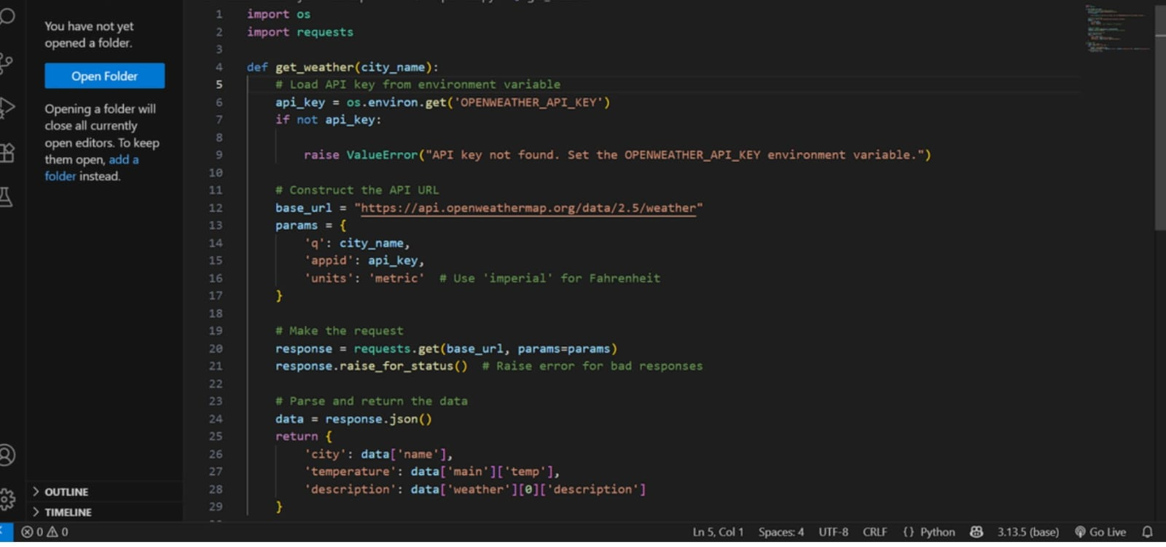

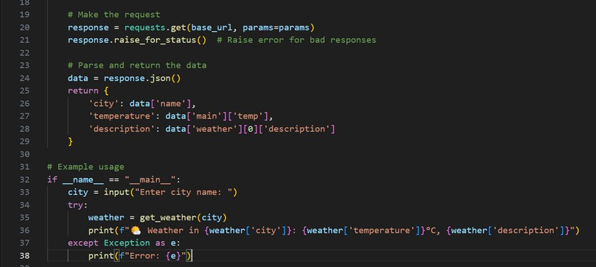
Generated Weather API Key:
After Environment Setup:
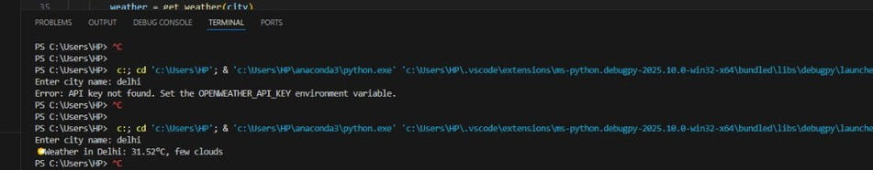

Task #1:
Prompt:
- Write a comment: # Function to check if a string is a valid palindrome (ignoring spaces and case) and allow Copilot to complete it.
Code Generated:
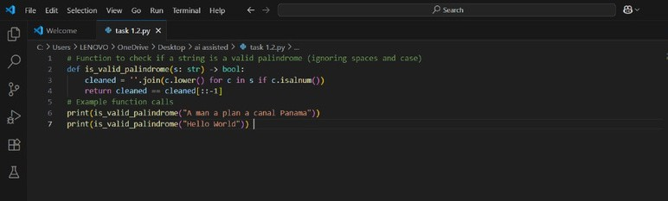
Output After executing Code:

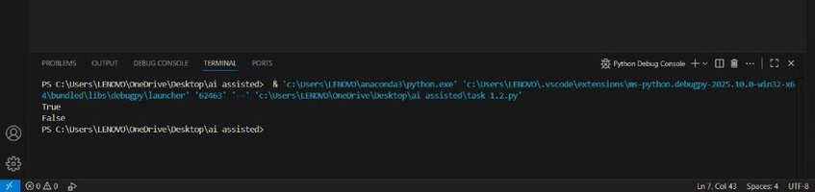
Your Observations:
The observation from the above code is:

The function is_valid_palindrome checks if a given string is a palindrome, ignoring spaces, punctuation, and case.
When called with "A man a plan a canal Panama", it returns True because this phrase is a palindrome when spaces and case are ignored.
When called with "Hello World", it returns False because this phrase is not a palindrome.

TASK #2:

Prompt:
- Generate a Python function that returns the Fibonacci sequence up to n terms. Prompt with only a function header and docstring
Code Generated:
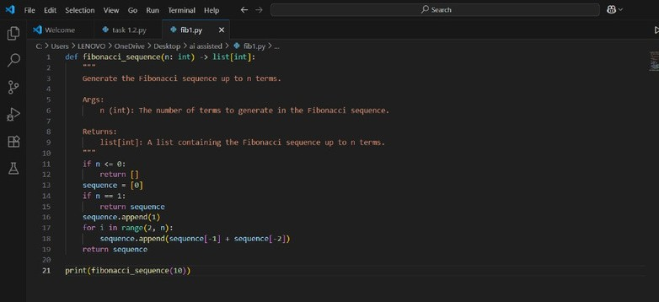
Output After executing Code:
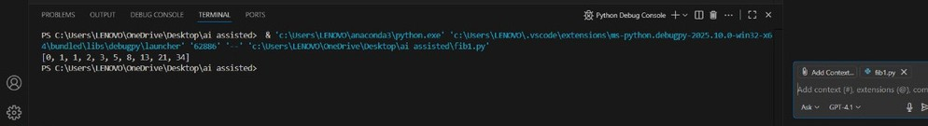
Your Observations:
- Correct Fibonacci Logic:

The function correctly generates the Fibonacci sequence using iteration. It handles edge cases like n <= 0 and n == 1.
- Python Type Hints Used:
The function signature uses type hints (n: int -> list[int]), which improves code readability and helps with static analysis tools.
- Docstring Included:
There’s a detailed docstring explaining the arguments and return type, which is great for documentation and usability.
- Edge Case Handling:
The function checks for non-positive n and handles n == 1 separately, preventing index errors.
- Clean and Readable Code:
Indentation, spacing, and variable naming are clear and follow Python conventions.
- Execution Output Verifled:
The terminal shows the correct output of the first 10 Fibonacci numbers

TASK #3:

Prompt:
- Write a comment like # Function to reverse a string and use Copilot to generate the function.
Code Generated:
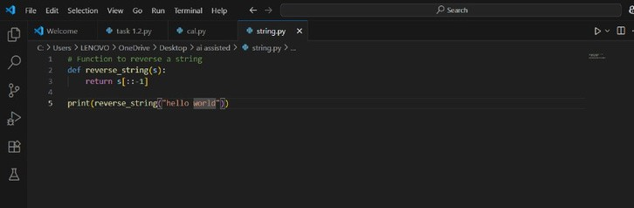
Output After executing Code:
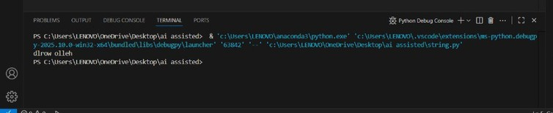
Observations:
- Correct String Reversal Logic:
The use of Python slicing [::-1] is a concise and efficient way to reverse a string.
- Simple and Clean Implementation:
The code is minimal, readable, and directly focuses on the core task of reversing a string.
- Appropriate Function Use:
The logic is wrapped inside a function (reverse_string), which makes the code reusable.
- Function Successfully Tested:

The output in the terminal (dlrow olleh) confirms that the function works correctly for the input "hello world".
- Comment for Clarity:
There is a comment at the top of the script that explains the purpose of the function.

TASK #4:

Prompt:
Generate a program that simulates a basic calculator (add, subtract, multiply, divide). Write the comment: # Simple calculator with 4 operations and let AI complete
Code Generated:
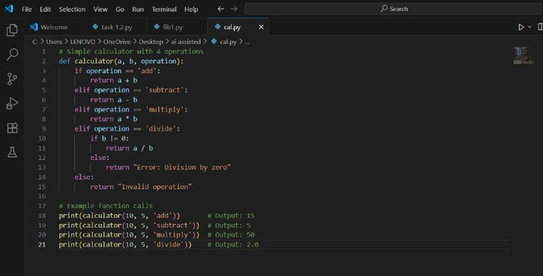
Output After executing Code:
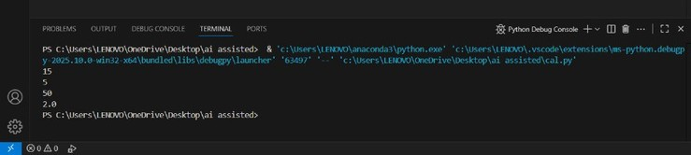
Your Observations:
- Functional Calculator Implementation:
The calculator function handles the four basic arithmetic operations: addition, subtraction, multiplication, and division.
- Input Flexibility:
The function takes three parameters: two numbers and a string indicating the operation — simple and user- friendly design.
- Division by Zero Check:
Great job handling the divide case carefully by checking if b != 0 to avoid runtime errors.

TASK #5:

Prompt:
Use a comment to instruct AI to write a function that reads a file and returns the number of lines
Code Generated:
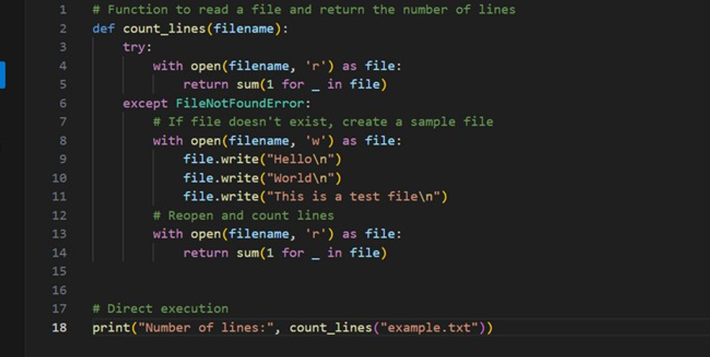
Output After executing Code:
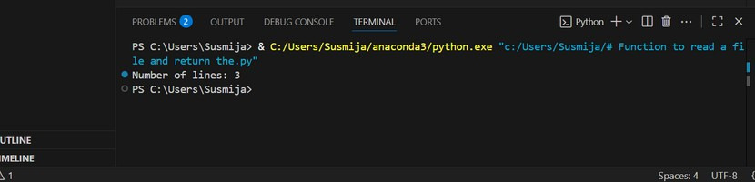
Your Observations:
- Correct Function Purpose:
The function count_lines(filename) is designed to: Read a file and count its number of lines.
If the file doesn’t exist, it creates a default one and then counts the lines.

Proper Use of Exception Handling:
The try-except block catches a File Not Found Error and handles it gracefully by creating a sample file.
This prevents the program from crashing due to a missing file.

- Efficient Line Counting Logic:
Uses generator expression to count lines:

sum(1 for _ in file)
This is memory-efficient and Pythonic.

Sample File Created with 3 Lines:
The file is created with 3 specific lines: Hello
World
This is a test file

Clear Output Statement:
Displays the result to the user using:
print("Number of lines:", count_lines("example.txt")

